Zlata Seregina
University of the People
MATH 1211 - Calculus
Mihir Panchal
April 15, 2026

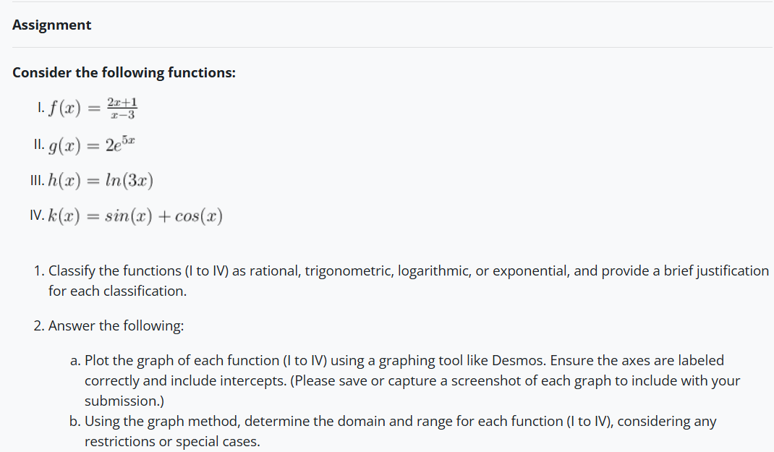

- $\text{f}\text{(}\text{x}\text{)=}\frac{\text{2}\text{x}\text{+1}}{\text{x}\text{−3}}$
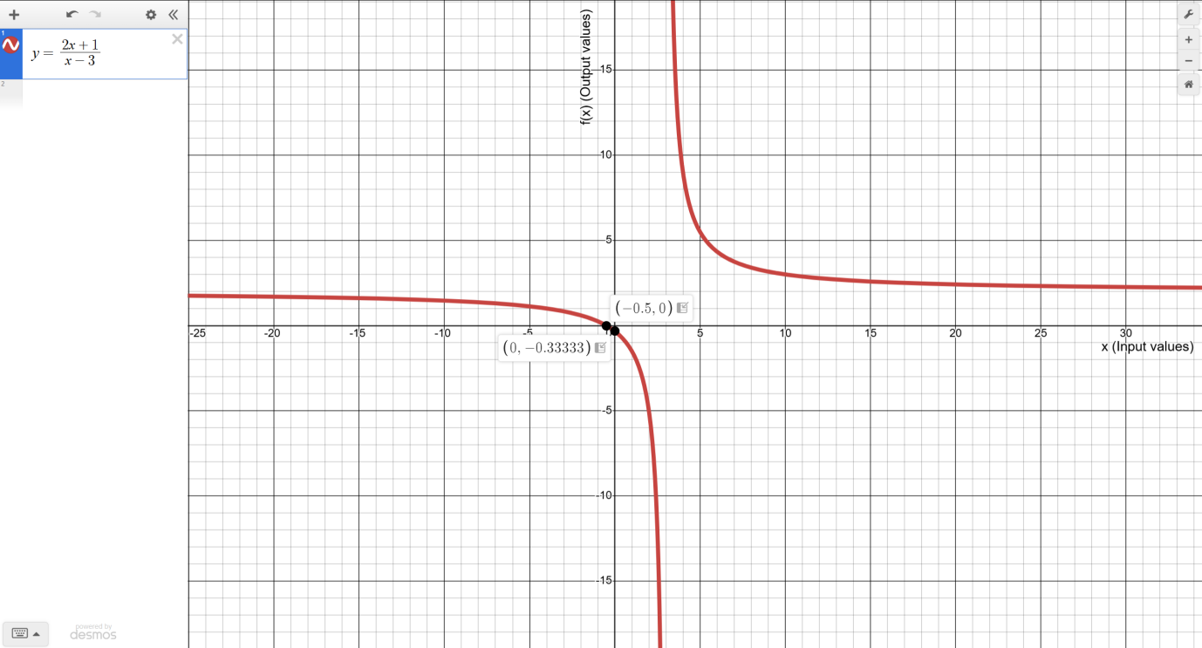
Classification:
Rational function
Justification:
I noticed that the curve gets very close to the vertical line x=3 but never actually touches it. From this, I understood that the function is undefined at x=3, which aligns perfectly with what I learned about rational functions. Herman & Strang (2024) explain, “Just as rational numbers are quotients of integers, rational functions are quotients of polynomials. In particular, a rational function is any function of the form f(x)=p(x)/q(x), where p(x) and q(x) are polynomials.”
Domain:
By observing the graph, I can see that the function exists for all x-values except x = 3. The vertical asymptote clearly marks the restriction.
$$\text{(−∞,3)∪(3,∞)}$$
Range:
Looking at the y-values, I noticed the curve approaches y=2 as x becomes very large in either direction, but it never actually reaches this value. This shows that the horizontal asymptote restricts the range at y = 2.
$$\text{(−∞,2)∪(2,∞) }$$

- $\text{g}\text{(}\text{x}\text{)=}{\text{2}\text{e}}^{\text{5}\text{x}}$
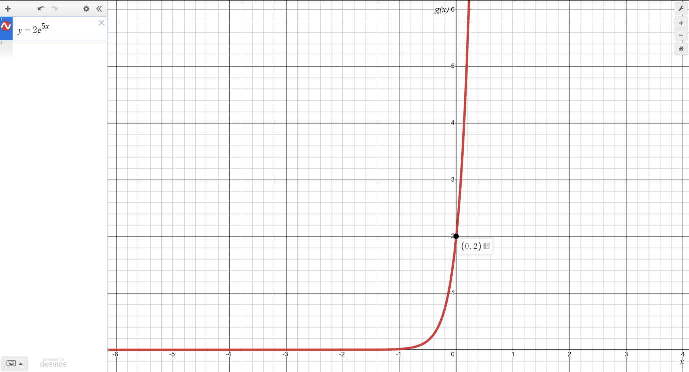
Classification:
Exponential Function
Justification:
When I plotted this graph, I noticed that the curve is always above the x-axis and rises very sharply as x increases. For negative x-values, the graph approaches zero but never touches it. This immediately reminded me that exponential functions grow rapidly in one direction and decay toward zero in the other, which is exactly what Herman & Strang (2024) describe: “More generally, any function of the form f(x)=b^x, where b>0,b=1, is an exponential function with base b and exponent x. Exponential functions have constant bases and variable exponents.”
Domain:
From the graph, I could see that the function exists for all x-values, meaning there are no breaks or restrictions.
$$\text{(−∞,∞)}$$
This aligns with what Herman & Strang (2024) explain: “For any base b>0, the exponential function b^x is defined for all real numbers.”
Range:
Observing the graph, I can see that the y-values never go below zero. The function approaches zero as x becomes very negative, but it continues to rise without bound for positive x.
$$\text{(0,∞)}$$

- $\text{h(}\text{x}\text{)=}\text{ln}\text{(3}\text{x}\text{)}$
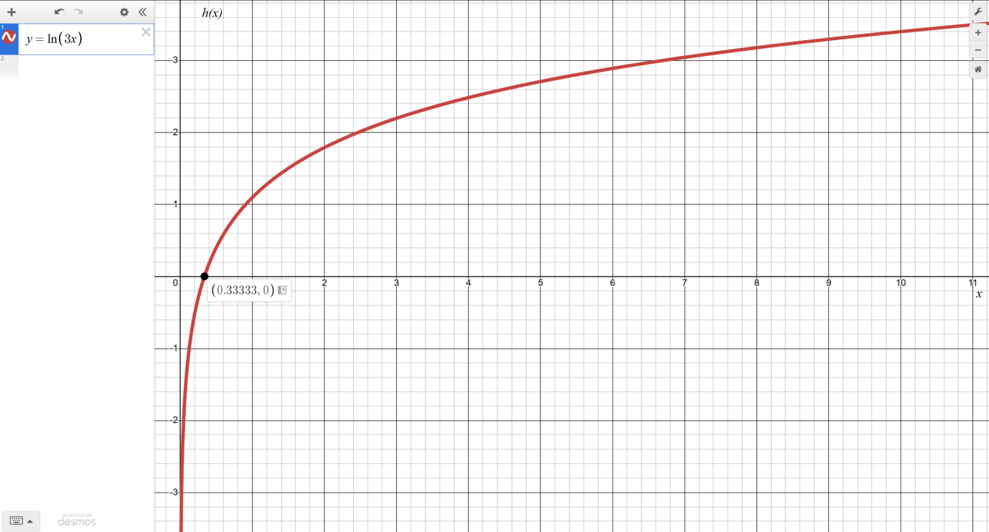
Classification:
Logarithmic Function
Justification:
When I graphed this function, the first thing I noticed is that the curve only exists for x-values greater than 0. The graph approaches a vertical line at x=0, which clearly shows that the function is undefined for x ≤ 0. Herman & Strang (2024) explain this property of logarithmic functions: “For any base b>0, the exponential function b^x is defined for all real numbers, so the domain is (−∞,∞) and the range is (0,∞). The exponential function b^x is one‑to‑one… Therefore, it has an inverse function, called the logarithmic function with base b… The logarithmic function with base b, denoted ${\text{log}}_{\text{b}}{\text{(}\text{x}\text{)}}$, has domain (0,∞) and range (−∞,∞), and satisfies ${\text{log}}_{\text{b}}{\text{(}\text{x}\text{)=}\text{y}}$ if and only if b^y=x.”
Domain:
Observing the graph confirms that the curve starts just to the right of x = 0 and continues infinitely to the right. This shows the domain is:
$$\text{(0,∞)}$$
Range:
I see that the curve climbs gradually as x increases, and it goes down without bound as x approaches 0. This demonstrates that the function can take all real values, so the range is:
$$\text{(−}\text{∞}\text{,∞)}$$

- $\text{k}\text{(}\text{x}\text{)=}\text{sin}\text{(}\text{x}\text{)+}\text{cos}\text{(}\text{x}\text{)}$
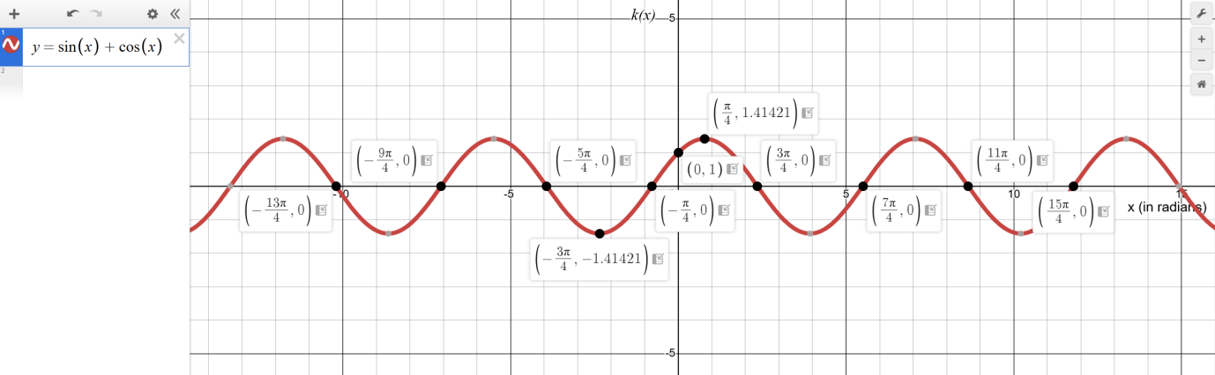
Classification:
Trigonometric Function
Justification:
When I graphed $\text{k(x)=sin(x)+cos(x)}$, I noticed the wave pattern that repeats regularly. It looks like a sine wave, but shifted and scaled. From the graph, I could see that the highest point of the wave is approximately 1.414 (which is $\sqrt{\text{2}}$) and the lowest point is approximately -1.414. The graph oscillates up and down regularly, never stopping, which makes sense because sine and cosine are periodic functions. Herman & Strang (2024) explain this: “Since the angle $\text{θ + 2π}$ correspond to the same point… the trigonometric functions are periodic functions. The sine, cosine… have a period of $\text{2π.}$”
Domain:
Looking at the graph, I can see that it continues infinitely in both directions along the x-axis. There are no breaks or restrictions, so I concluded that the domain is all real numbers:
$$\text{(−∞,∞)}$$
This makes sense because sine and cosine are defined for every real x. As Herman & Strang (2024) explain, “Some functions…cannot be described by basic algebraic operations. These functions are known as transcendental functions… The most common transcendental functions are trigonometric, exponential, and logarithmic functions.”
Range:
From the graph, I can observe that the y-values oscillate between $\text{−1.414≈−}\sqrt{\text{2}}$ and $\text{1.414≈}\sqrt{\text{2}}$.
$$\left[\text{−}\sqrt{\text{2}}\text{,+}\sqrt{\text{2}}\right]$$
or
$$\left[\text{−1.414,+1.414}\right]$$
This represents the maximum and minimum values of the combined sine and cosine function.

References
Yoshiwara, K. (2020). Modeling, functions, and graphs. American Institute of Mathematics. https://yoshiwarabooks.org/mfg/MFG.html
Herman, E. & Strang, G. (2024). Calculus volume 1. OpenStacks. Rice University. https://openstax.org/details/books/calculus-volume-1

